**DEPARTMENT OF INFORMATION TECHNOLOGY**

**COURSE CODE: DJS22ITL306 DATE: 1411/23**

**COURSE NAME: Programing Laboratory 1 (Advanced Java) SAP ID : 60003220045**

**CLASS: S.Y B. Tech IT NAME : Anish Sharma**

**EXPERIMENT NO.4**

**CO/LO:**

**CO1**- Modify the behavior of methods, classes, and interfaces at runtime.

**AIM / OBJECTIVE:**

For a given problem statement build an application having multiple frames with Java Beans.

**PROBLEM STATEMENTS:**

**1.** Write a Java program to create multiple frames containing personal information, educational information and extra-curricular achievements.

Provide an option to go back and forth from one frame to another frame.

Submit button on last frame should pop up a dialogue box showing successful message.

Include all the below mentioned components in above frames wherever applicable, Text field, label, panel, radio button, check boxes, combo box, text area, list.

**CODE:**

**Main Java File:**

/*

* To change this license header, choose License Headers in Project Properties. * To change this template file, choose Tools | Templates * and open the template in the editor.

*/ package

resume;

/**

*

* @author DJSCE.Student

*/

public class Resume {

/**

* @param args the command line arguments

*/ public static void main(String[] args) {

// TODO code application logic here PersonalDetails pd = new PersonalDetails(); pd.setVisible(true);

}

}

**Frame 1:**

package resume;

/**

*

* @author DJSCE.Student

*/ public class PersonalDetails extends

javax.swing.JFrame {

/**

* Creates new form PersonalDetails

*/ public

PersonalDetails() { initComponents();

} /**

* This method is called from within the constructor to initialize the form. * WARNING: Do NOT modify this code. The content of this method is always * regenerated by the Form Editor.

*/

@SuppressWarnings("unchecked") private void jButton1ActionPerformed(java.awt.event.ActionEvent evt) { eduQualification q = new eduQualification();

q.setVisible(true);

// TODO add your handling code here:

} private void jTextField1ActionPerformed(java.awt.event.ActionEvent evt) { // TODO add your handling code here:

} private void jRadioButton1ActionPerformed(java.awt.event.ActionEvent evt) { // TODO add your handling code here:

} private void jTextField3ActionPerformed(java.awt.event.ActionEvent evt) { // TODO add your handling code here:

}

/**

* @param args the command line arguments

*/ public static void main(String args[]) {

/* Set the Nimbus look and feel */

//<editor-fold defaultstate="collapsed" desc=" Look and feel setting code (optional) "> /* If Nimbus (introduced in Java SE 6) is not available, stay with the default look and feel.

* For details see http://download.oracle.com/javase/tutorial/uiswing/lookandfeel/plaf.html

*/ try { for (javax.swing.UIManager.LookAndFeelInfo info : javax.swing.UIManager.getInstalledLookAndFeels()) { if ("Nimbus".equals(info.getName())) { javax.swing.UIManager.setLookAndFeel(info.getClassName());

break;

}

}

} catch (ClassNotFoundException ex) { java.util.logging.Logger.getLogger(PersonalDetails.class.getName()).log(java.util.logging.Level.

SEVERE, null, ex);

} catch (InstantiationException ex) {

java.util.logging.Logger.getLogger(PersonalDetails.class.getName()).log(java.util.logging.Level.

SEVERE, null, ex);

} catch (IllegalAccessException ex) {

java.util.logging.Logger.getLogger(PersonalDetails.class.getName()).log(java.util.logging.Level.

SEVERE, null, ex);

} catch (javax.swing.UnsupportedLookAndFeelException ex) { java.util.logging.Logger.getLogger(PersonalDetails.class.getName()).log(java.util.logging. Level. SEVERE, null, ex);

}

//</editor-fold>

/* Create and display the form */

java.awt.EventQueue.invokeLater(new Runnable() { public void run() { new

PersonalDetails().setVisible(true); }

});

}

// Variables declaration - do not modify private javax.swing.JButton jButton1; private javax.swing.JLabel jLabel1; private javax.swing.JLabel jLabel2; private javax.swing.JLabel jLabel3; private javax.swing.JLabel jLabel4; private javax.swing.JLabel jLabel5; private javax.swing.JRadioButton jRadioButton1; private javax.swing.JRadioButton jRadioButton2; private javax.swing.JTextField jTextField1; private javax.swing.JTextField jTextField2; private javax.swing.JTextField jTextField3;

// End of variables declaration }

**Frame 2:**

package resume;

/**

*

* @author DJSCE.Student

*/ public class eduQualification extends

javax.swing.JFrame {

/**

* Creates new form eduQualification

*/

public eduQualification() { initComponents();

} /**

* This method is called from within the constructor to initialize the form. * WARNING: Do NOT modify this code. The content of this method is always * regenerated by the Form Editor.

*/

@SuppressWarnings("unchecked") private void jButton1ActionPerformed(java.awt.event.ActionEvent evt) { // TODO add your handling code here:

PersonalDetails pd = new PersonalDetails();

pd.setVisible(true);

}

private void jButton2ActionPerformed(java.awt.event.ActionEvent evt) { // TODO add your handling code here: extraCuricular ec = new extraCuricular();

ec.setVisible(true);

} private void jTextField1ActionPerformed(java.awt.event.ActionEvent evt) { // TODO add your handling code here:

}

private void jTextField2ActionPerformed(java.awt.event.ActionEvent evt) { // TODO add your handling code here:

} private void jTextField3ActionPerformed(java.awt.event.ActionEvent evt) { // TODO add your handling code here:

} private void jTextField4ActionPerformed(java.awt.event.ActionEvent evt) { // TODO add your handling code here:

} private void jTextField5ActionPerformed(java.awt.event.ActionEvent evt) { // TODO add your handling code here:

}

/**

* @param args the command line arguments

*/ public static void main(String args[]) { /* Set the Nimbus look and feel */

//<editor-fold defaultstate="collapsed" desc=" Look and feel setting code (optional) "> /* If Nimbus (introduced in Java SE 6) is not available, stay with the default look and feel.

* For details see http://download.oracle.com/javase/tutorial/uiswing/lookandfeel/plaf.html

*/ try { for (javax.swing.UIManager.LookAndFeelInfo info : javax.swing.UIManager.getInstalledLookAndFeels()) { if ("Nimbus".equals(info.getName())) { javax.swing.UIManager.setLookAndFeel(info.getClassName());

break;

}

}

} catch (ClassNotFoundException ex) {

java.util.logging.Logger.getLogger(eduQualification.class.getName()).log(java.util.logging.Leve l.SEVERE, null, ex);

} catch (InstantiationException ex) { java.util.logging.Logger.getLogger(eduQualification.class.getName()).log(java.util.logging.Leve l.SEVERE, null, ex);

} catch (IllegalAccessException ex) {

java.util.logging.Logger.getLogger(eduQualification.class.getName()).log(java.util.logging.Leve l.SEVERE, null, ex);

} catch (javax.swing.UnsupportedLookAndFeelException ex) {

java.util.logging.Logger.getLogger(eduQualification.class.getName()).log(java.util.logging.Leve l.SEVERE, null, ex);

}

//</editor-fold>

/* Create and display the form */

java.awt.EventQueue.invokeLater(new Runnable() { public void run() { new eduQualification().setVisible(true); }

});

}

// Variables declaration - do not modify private javax.swing.JButton jButton1; private javax.swing.JButton jButton2; private javax.swing.JLabel jLabel1; private javax.swing.JLabel jLabel5; private javax.swing.JLabel jLabel6; private javax.swing.JLabel jLabel7; private javax.swing.JLabel jLabel8; private javax.swing.JLabel jLabel9; private javax.swing.JTextField jTextField1; private javax.swing.JTextField jTextField2; private javax.swing.JTextField jTextField3; private javax.swing.JTextField jTextField4; private javax.swing.JTextField jTextField5;

// End of variables declaration }

**Frame 3:**

package resume; import javax.swing.JOptionPane;

/**

*

* @author DJSCE.Student

*/ public class extraCuricular extends

javax.swing.JFrame {

/**

* Creates new form extraCuricular

*/

public extraCuricular() { initComponents();

} /**

* This method is called from within the constructor to initialize the form. * WARNING: Do NOT modify this code. The content of this method is always * regenerated by the Form Editor.

*/

@SuppressWarnings("unchecked") private void SubmitActionPerformed(java.awt.event.ActionEvent evt) {

JOptionPane.showMessageDialog(this,"Data saves succesfully");

System.exit(0);

// TODO add your handling code here:

JOptionPane.showMessageDialog(null, "Form submitted Successfully!", "Alert", JOptionPane.INFORMATION_MESSAGE);// TODO add your handling code here:

} private void jButton1ActionPerformed(java.awt.event.ActionEvent evt) { // TODO add your handling code here:

eduQualification eq = new eduQualification();

eq.setVisible(true);

}

/**

* @param args the command line arguments

*/ public static void main(String args[]) {

/* Set the Nimbus look and feel */

//<editor-fold defaultstate="collapsed" desc=" Look and feel setting code (optional) "> /* If Nimbus (introduced in Java SE 6) is not available, stay with the default look and feel.

* For details see http://download.oracle.com/javase/tutorial/uiswing/lookandfeel/plaf.html

*/ try { for (javax.swing.UIManager.LookAndFeelInfo info : javax.swing.UIManager.getInstalledLookAndFeels()) { if ("Nimbus".equals(info.getName())) { javax.swing.UIManager.setLookAndFeel(info.getClassName());

break;

}

}

} catch (ClassNotFoundException ex) {

java.util.logging.Logger.getLogger(extraCuricular.class.getName()).log(java.util.logging.Level.S EVERE, null, ex);

} catch (InstantiationException ex) {

java.util.logging.Logger.getLogger(extraCuricular.class.getName()).log(java.util.logging.Level.S EVERE, null, ex);

} catch (IllegalAccessException ex) {

java.util.logging.Logger.getLogger(extraCuricular.class.getName()).log(java.util.logging.Level.S EVERE, null, ex);

} catch (javax.swing.UnsupportedLookAndFeelException ex) {

java.util.logging.Logger.getLogger(extraCuricular.class.getName()).log(java.util.logging.Level.S EVERE, null, ex);

}

//</editor-fold>

/* Create and display the form */ java.awt.EventQueue.invokeLater(new Runnable() { public void run() {

new extraCuricular().setVisible(true);

}

});

}

// Variables declaration - do not modify private javax.swing.JButton Submit; private javax.swing.JButton jButton1; private javax.swing.JLabel jLabel1; private javax.swing.JLabel jLabel2; private javax.swing.JScrollPane jScrollPane1; private javax.swing.JTextArea jTextArea1;

// End of variables declaration

}

**Output :**

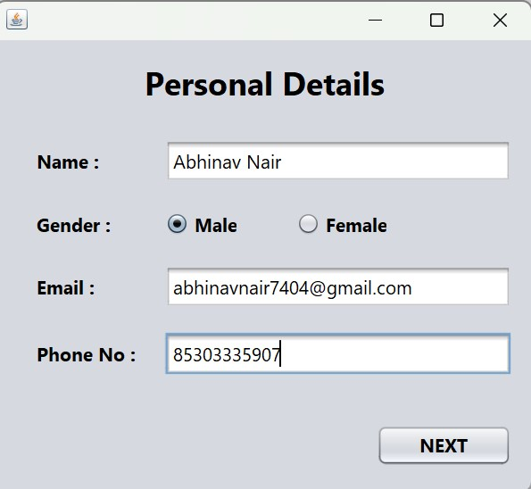

anish@gmail.com

1234567890

Anish Sharma

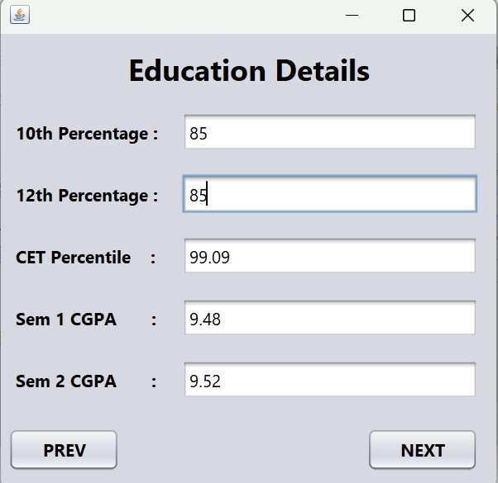

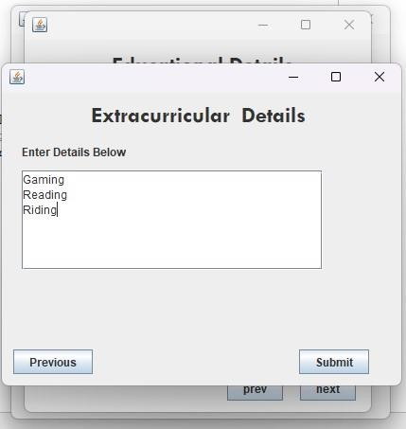

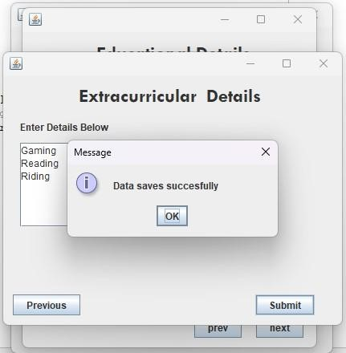

**OBSERVATION:**

Describe various components used with their usability?

Some of the important and common components of the Java Swing class are:

1. JFrame: JFrame is a top-level container that represents the main window of a GUI application. It provides a title bar, and minimizes, maximizes, and closes buttons.
2. JPanel: JPanel is a container that can hold other components. It is commonly used to group related components together.
3. JButton: JButton is a component that represents a clickable button. It is commonly used to trigger actions in a GUI application.
4. JLabel: JLabel is a component that displays text or an image. It is commonly used to provide information or to label other components.
5. JTextField: JTextField is a component that allows the user to input text. It is commonly used to get input from the user, such as a name or an address.
6. JCheckBox: JCheckBox is a component that represents a checkbox. It is commonly used to get a binary input from the user, such as whether or not to enable a feature.
7. JList: JList is a component that represents a list of elements. It is typically used to display a list of options from which the user can select one or more items.
8. JTable: JTable is a component that represents a data table. It is typically used to present data in a tabular fashion, such as a list of products or a list of orders.
9. JScrollPane: JScrollPane is a component that provides scrolling functionality to other components. It is commonly used to add scrolling to a panel or a table.

**CONCLUSION:**

**With the help of experiment 4 we have learnt the use of different components of swings**